

PR01157 - MAP Stamping Overhead Conveyor System

Group Hold

Version 1.0

Mar 6 2012

Honda of America Mfg., Inc.
MFG-IT Information Services

Revision History
Revision | Section | Description | Editor | Date
1.0 | All | Previous Group Hold Specifications | K. Nichols | 01/25/2012
1.1 | All | Initial Version – Adapted from original tech spec document | A. Kendell | 03/06/2012

Reviewers

Name | Position | Version Reviewed | Comments

Distribution List

Name | Position | Version  Distributed | Location

Approvals

By Signing and approving this requirements document and its related documents, you agree that:
  - The requirements stated herein describe accurately and completely the functionality that you require within the scope of this requirement and,
  - All other decisions and details with respect to the development and implementation of these requirements will be left to the developers.

Name | Position | Date Approved | Version Approved | Signature

Table of Contents

1. Group Hold 4
1.1. Brief Description 4
1.2. Pre-Conditions 4
1.3. Post-Conditions 4
1.4. Actors 4
1.5. Workflow 5
1.5.1. Alternate Workflow 5
1.6. System Requirements 5
1.6.1. Batch Purge Requirements 5
1.7. Extension Points 6
1.7.1. First Extension Point 6
1.8. Inclusion Points 6
1.8.1. First Inclusion Point 6
1.9. Implementation Approach 6
1.10. Generalizations 6
1.11. Use Case Diagrams 6
1.12. Other Diagrams 7
1.12.1. Activity Diagram 7
1.12.2. Sequence Diagram 7
1.12.3. ERD Reference 7
1.13. Storyboards 9
1.13.1. SRM Purge 9
1.14. Traceability 10
1.15. Appendix 10
1.15.1. Purge Draft WorkItem 10
1.15.2. Purge Rejected WorkItem 10
1.15.3. Purge Approved Worklist 10
1.15.4. Purge Inactive Contacts 11
1.15.5. Purge Inactive Roles 11

Group Hold

Brief Description

The purpose of this use case is to describe a new feature that will allow a user to change the status of a group of carriers. This feature is a necessary component to the OHCV system to ensure that defects do not get passed on to the weld department.

Business Requirements

- Ability to set the carrier status of all of the carriers that contain parts for an entire production run.
- Ability to set the carrier status of all of the carriers in a storage system row.
- Ability to set the carrier status of a specified number of carriers before and/or after a given carrier based on the production run.

Actors

- User
- System

Workflow
 | The User opens the Group Hold screen | - User decides that multiple carriers need status updates and presses the “Group Hold” button.
 | The User enters
 | Extract Job completes | Use Case terminates

Alternate Workflow

Alternate Workflow 1 (Exception Path)

Step | Actor Action | System Response
- 1. | System encounters Database or file exception | System terminates with exception and System operator can see on the console and follow-up with the system support person. The Use case terminates.

System Requirements

Screens

- Carrier Update
  - Add an “Update Group” button
    - Click will submit the current carrier update
    - Navigate to Update Group screen
  - Add a list of defects
    - Shows all defects associated with the parts on a particular carrier
    - Allows a user to Add, Modify, or Correct a defect.

- Update Group
  - Production run number selector
    - Default value will depend on how this screen was reached
      - Carrier Update: the production run number of the edited carrier
      - Main Menu: blank
    - Contains a list of production run numbers of the parts currently in storage
  - Carrier status selector
    - Contains list of possible carrier status selections
    - Default value: blank
  - Production Run Date
    - Allow easy selection of date and time
    - Format: mm/dd/yyyy hh:mm:ss
    - Default value will depend on how this screen was reached
      - Carrier Update: production run date of the edited carrier
      - Main Menu: blank
  - Previous Carriers
    - Allows selection of numeric values
      - Minimum of 1
      - Maximum of 999

- Update Confirmation Screen
  - Shows all fields Status

- System shall never allow purging of an approved supplier or supplier.

- System shall all delete orphan companies

- System shall also delete orphan address. That is detached address.

Extension Points

First Extension Point
- None

Inclusion Points

First Inclusion Point

- None

Implementation Approach

This use case shall, be implemented as a nightly batch process.

Generalizations

Use Case Diagrams

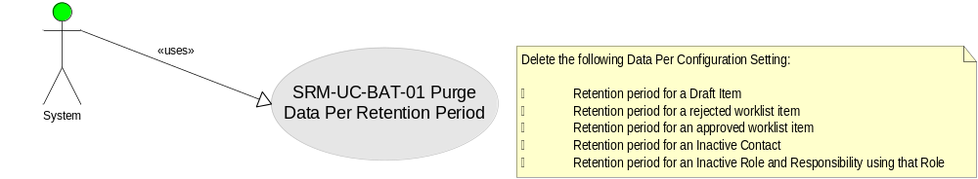

Other Diagrams

Activity Diagram

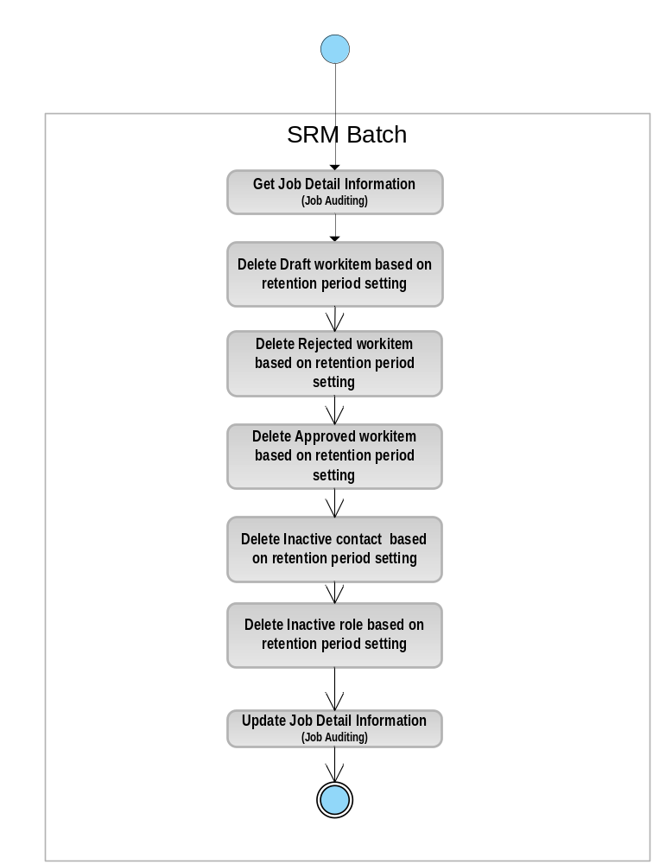

Sequence Diagram

ERD Reference

* For ERD accuracy please, refers to the most recent ERD.
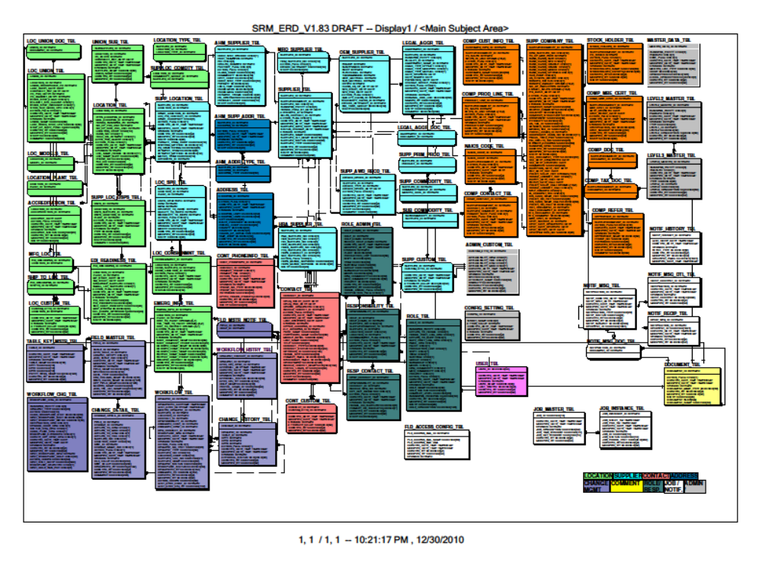

Storyboards

SRM Purge

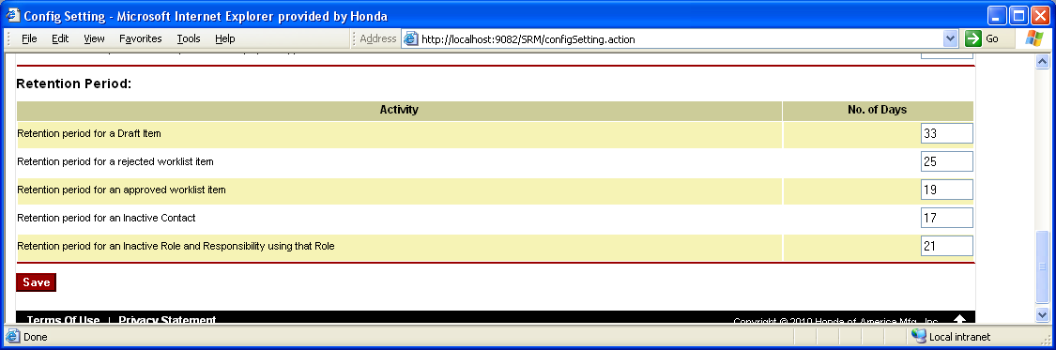

Traceability

Appendix

Purge Draft WorkItem

SELECT *
FROM SRMAPP.WORKFLOW_TBL A
WHERE DAYS(CURRENT DATE) - DAYS(COALESCE(MODIFIED_DATE_TIME, CREATED_DATE_TIME))
> (SELECT ATTRIB_VALUE FROM SRMAPP.CONFIG_SETTING_TBL WHERE SHORT_NAME = 'Q1')
AND WORKFLOW_STATUS = 'DRAFT'
AND REQUEST_STATUS = 'OPEN'

- Select data from the above SQL
- Delete associated supplier, location, company and contacts. (Delete all associations)

Purge Rejected WorkItem

SELECT *
FROM SRMAPP.WORKFLOW_TBL A
WHERE DAYS(CURRENT DATE) - DAYS(COALESCE(MODIFIED_DATE_TIME, CREATED_DATE_TIME)) >
(SELECT ATTRIB_VALUE FROM SRMAPP.CONFIG_SETTING_TBL WHERE SHORT_NAME = 'R1')
AND REQUEST_STATUS = 'OPEN'
AND WORKFLOW_STATUS IN (.......) -- Use rejection status or use action flag to indicate
-- rejection
- Select data from the above SQL
- Delete associated supplier, location, company and contacts. (Delete all associations)

Purge Approved Worklist

SELECT *
FROM SRMAPP.WORKFLOW_TBL A
WHERE DAYS(CURRENT DATE) - DAYS(COALESCE(MODIFIED_DATE_TIME, CREATED_DATE_TIME)) >
(SELECT ATTRIB_VALUE FROM SRMAPP.CONFIG_SETTING_TBL WHERE SHORT_NAME = 'S1')
AND REQUEST_STATUS = 'CLOSED'
AND REQUEST_TYPE IN (
'Contact Update Req'
,'Supplier Review Req'
,'Field Changed'
,'Pending Inactive Contacts')

- Select data from the above SQL
- Delete associated work list history and change details. (Do not delete change history just detach the change ID)

Purge Inactive Contacts

SELECT *
FROM SRMAPP.CONTACT_TBL A
WHERE DAYS(CURRENT DATE) - DAYS(COALESCE(MODIFIED_DATE_TIME, CREATED_DATE_TIME))
> (SELECT ATTRIB_VALUE FROM SRMAPP.CONFIG_SETTING_TBL WHERE SHORT_NAME = 'T1')
AND CONTACT_STATUS = 'Inactive'

- Delete CONTACT and all its reference. (refer to ERD)

Purge Inactive Roles

SELECT *
FROM SRMAPP.ROLE_TBL A
WHERE DAYS(CURRENT DATE) - DAYS(COALESCE(MODIFIED_DATE_TIME, CREATED_DATE_TIME))
> (SELECT ATTRIB_VALUE FROM SRMAPP.CONFIG_SETTING_TBL WHERE SHORT_NAME = 'U1')
AND ROLE_STATUS = 'INACTIVE'

- Delete ROLE and all its reference. (refer to ERD)

